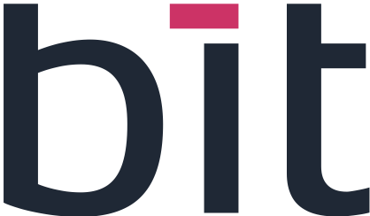 | 

INFINEON / BIT EXCELLENCE PROGRAM — 2026
WATER SUPPLY APP
Adaptations Made

1. Plants
- Block codes limited to 1 to 10 letters or digits — codes stay short and simple, and empty, overly long or special-character codes are refused.
- One block, one zone — a block can only be linked to a single zone, which removes any doubt about which zone supplies it and avoids counting the same water twice.
- New migration V13 — a one-time update of the database that finds blocks linked more than once and removes the duplicates, so that existing data follows the new rule.

2. Visitor Management
- Visit stops linked by name — the stops of a visit are now referred to by their name, and a new “Visit stops” panel was added to manage them.
- Visit ID is the Registration ID — the number used at registration now identifies the visit, so a single reference is used everywhere.
- Counter over the visit slot — the counter now adds up the water over the whole visit slot. The 15-minute interval is only used to calculate the flow rate.
- Roles on safety instructions — it is now specified which roles apply to the safety instructions.

3. Product Transformation
- Quality test valid for 7 days — a water quality test remains valid for 7 days before the batch.
- One test per tank — every tank used by the batch must have its own test, so one test cannot cover several tanks.
- Decisions made — the batchId they provide is used as the lotId, and both sorting and drying are sent under the generic type OTHER.

Summary in One Paragraph
In short
The new features were adjusted to follow clear rules. Plant block codes and zone links were restricted and existing duplicates cleaned up, visits are identified and counted in a more consistent way, and product batches now require a recent quality test for each tank used.

